Taking Action: Students as Global Citizens
Methodist Ladies’ College “On the Move”
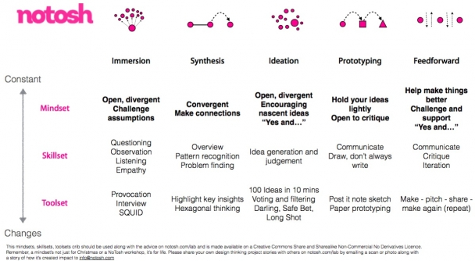
Through this design-thinking approach, the Year 6 students developed a deeper understanding of the problems facing migrants and became articulate at presenting problems and a range of well-researched, possible solutions to these problems.

The students immersed themselves in the issues surrounding migration.
Through this process, during English, Mathematics and History, they were able to identify a specific problem facing migrants.

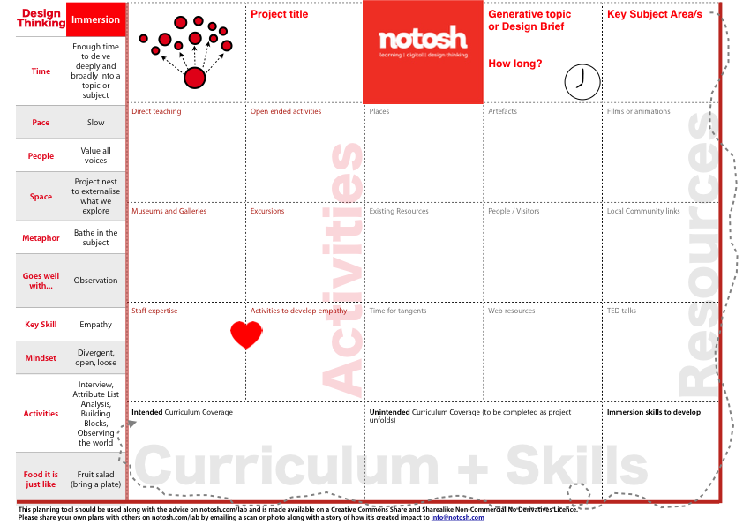
Once the students had identified a key problem that interested them, they came up with their own solutions to that particular problem. They researched their solutions to identify any issues arising and utilised their research to further develop their solution. Next, they created a prototype through a critical feedback process and finally, pitched their idea/prototype to an audience of their peers.
The Pitch: How Might We Statement, Solution, Who can help you to achieve this? Who will benefit from your ideas? In what ways will they benefit? What are the challenges you have to overcome in launching your ideas? How are you going to let others know about your idea? How will you measure if your idea has been beneficial?

Teachers: Colin Fallon, Louise Kennedy, Lucy Nippierd and Jodie Spencer

