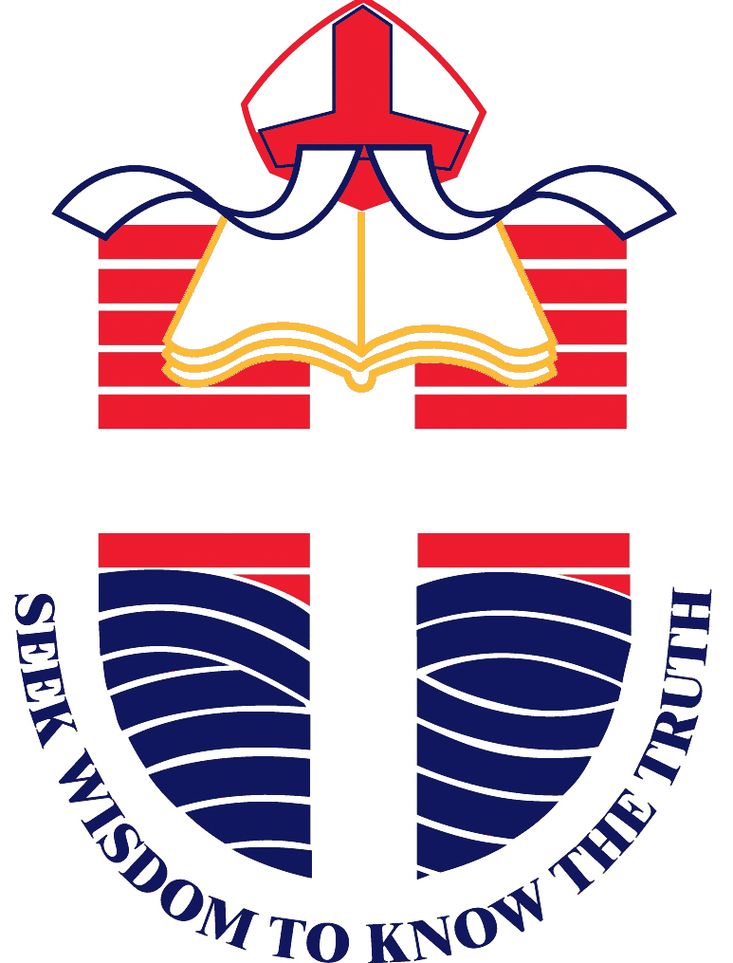
SUSTAINABILITY IN THE 21ST CENTURY
JOHN WOLLASTON ANGLICAN COMMUNITY SCHOOL

At John Wollaston, we are an IB World School that follows the Kath Murdoch Inquiry Cycle. Therefore the students used this process when completing their units of inquiry and the PYP Exhibition.
Finding Out
How the world works
- Conducting case studies of countries that Room to Read support
- Exploration of concept of sanitation
- Guided reading sessions – texts about sustainable practices
- Science – exploring reversible and irreversible changes to materials
Exhibition
- Students create concept questions about a world issue that they chose.
- PYP concepts: Form, Function, Causation, Change, Connection, Perspective, Responsibility, Reflection
- The students answer their 8 concept questions through research.
Tuning In
How the world works
- Video – Man destroying the Earth
- Writing prompt – what will the world look like in 2065?
- Cookie Mining
Exhibition
- Room to read book swap
- Reach out Manila guest speakers
- Ranya Alkadamani: Skype call about Sweaters for Syria
- In Search of Safety Incursion: Red Cross

Sorting Out
How the world works
- Looking through the PYP Concept lenses during guided reading
- Demonstration of creating water filters with the ‘ideal materials’
Exhibition
- The students create surveys to find out information from the school community about their topic. It can be related to opinions or perspectives, the students might be trying to relate their topic to the school community (i.e. discrimination – bullying)

Synthesising and reflecting
How the world works
- Book Swap
- Summative Assessment – creating your own sustainable town
Exhibition
- The students decide what action they are going to take in regards to their global issue.
- In the past we have had students create: brochures, models, websites, activity days, write picture books, make changes to the school diary, design a nature playground for our school
- This is where they shine as global and active citizens.
- Students reflect on how their action addresses the central
idea and lines of inquiry

Going Further
How the world works
- Students created water filters choosing own materials
Exhibition
- Students choose a concept question that interests them the most. They ask themselves whether there is any information missing or any information that they need to build on. From here, they then decide what action they might take from all the research they have found.
- Persuasive argument is written about the importance of their topic

Curriculum links:
English
- Creating texts: Persuasive writing. Year 6 students wrote persuasive letters to members of parliament regarding sustainability and environmental issues. These letters focused on the conventions of pathos, ethos and logos. Persuasive arguments continued in the going further stage of Exhibition.
Humanities (including Ethical understanding, Intercultural understanding)
- Poverty, sustainability and human rights were explored through Terms 3 and 4. The “Room to Read” Book Swap that the Year 6’s undertook and lead helped the students to focus on rights, poverty and access to equal opportunities. The PYP Exhibition followed on from this inquiry in Term 4 and many students have begun to investigate global issues further.
Geography Skills
- Questioning and Researching; Analysing; Evaluating and; Communicating and Reflecting.
ICT (including Critical thinking)
- The Year 6 students used WIX to convey information about their new town, how it is sustainable and would reduce society’s use on finite resources. We were able to support students with the technical advice needed to set up a useful and productive website.
ICT General Capabilities
- Generating ideas, plans and processes; collaborating, sharing and exchanging and ; generating solutions to challenges and learning area tasks.

Year 6 contacts: Zayja Monteleone, Sheree Hancock, Glyn Teape
zmonteleone@jwacs.wa.edu.au ; shancock@jwacs.wa.edu.au ; gteape@jwacs.wa.edu.au

