Persuasive technique | Do not read this – Room to read (YOUTUBE link on Google classroom) | Syria – how war affects children clip (see World Vision link on Google classroom) | Teenage affluenza  (link on Google classroom stream) | What’s behind the label?  (World Vision link)
TEXT – emotive language
Modality/imperative
Statistics/facts
Subtitles
Font/Size/Colour
Rhetorical questions
Repetition
First or third person
AUDIO – music
Voice over –
Sound effects
Volume
VISUAL – choice of images
Colour
Movement
Photographs vs artistic
Animation
Written graphics
Use of narrator
Interview – expert
Interview – “victim”
Direct appeal to viewer
Use of humour/satire/irony
Call to action – what is it?
Order/flow of text
Intended audience?

Media (radio, TV, internet, social media, print etc.) can be an important tool for informing and influencing people’s opinion. Generally, it asks you, the viewer, to DO something – this can be a call to action or purchase or speak or share. Media uses more than just words – it uses music and images and voices to appeal to the viewer’s emotions, reason and values.
Aristotle identified three ways to persuade others – to appeal to their emotions, their thoughts or reason and their values. Place an E, T, V to show what appeal is being made by each persuasive text.
Emotions (pathos) | Thoughts/reason (logos) | Values and hopes (ethos)
Think about different techniques that appeal to each of the above and write them in the respective boxes. Here are some words to get you started: truth, outrage, statistics, expert opinion, fear, joy, graph, evidence, care, compassion, justice, sadness.
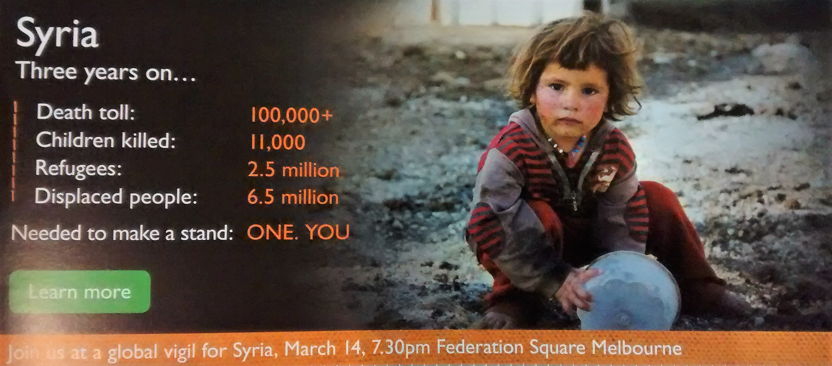
One formula for a persuasive text is: Attention - poster uses image of child and colour
Note how it is used in this digital poster Interest – “three years on..”, statistics, simple clear layout of information
Choose one of the texts from above and explain how it moves through this formula.
Desire – appeals to sense of humanity and justice, vulnerability
Action – “make a stand”, “learn more”, “join us”

